

Directorate | Manchester City Council - Adult Social Care
Document title | Safeguarding Adults Policy and Procedures  Part 2 – Safeguarding practice guidance and procedures
Summary | This document forms part 2/3 of safeguarding adults policy and procedures.  It contains details of the procedures to be followed where a safeguarding concern is raised.  This should be read alongside the Manchester Safeguarding Partnership (MSP) safeguarding policy and procedures
Date created | May 2024
Next Review Date | May 2026
Version | V3
Owner of policy | Head of Safeguarding - Amanda Baker
Date policy is signed off by DMT | 11th December 2024

Version Control | Description of change | Undertaken by who | Date
V3 | Amends to 5.10 | Brendan Gallagher | 19.9.25



Contents Page
- Policy Statement 4
- Scope 4
- Four Stages of Safeguarding 4-5
- Stage 1: Identifying a safeguarding concern 5-12
- Stage 2: Section 42 safeguarding enquiry 13-22
- Stage 3: Safeguarding plan and review 23-25
- Stage 4: Closing the safeguarding enquiry 25-27
- Timescales 27-28
- Organisational Abuse (complex/large scale enquiries) 28-35
- Version control, communication and cascading 35-36
- Storage and access to policy 36

1. Policy Statement
1.1. The stages of the safeguarding process are summarised in this document. There is scope at each stage to 'pause and review' to consider whether it is necessary to continue the safeguarding process or if it can be safely closed.
1.2 There is no requirement to go through all the stages of the process where this is not necessary. Decision making will be based on professional judgement and informed by a combination of the wishes of the adult, an analysis of risks and whether actions already taken have resolved the situation.
1.3 The timescales provided are guidelines only. If you are not able to meet the timescales, a record should be made within the safeguarding episode outlining the reasons for this.

2. Scope
2.1. These procedures relate to adult social care staff working within Manchester City
Council. Staff who are deployed to Manchester Local Care Organisation (MLCO) or Greater Manchester Mental Health Trust (GMMH) will be expected to comply with their respective organisations policies and procedures.

3. Four Stages of Safeguarding
Stage 1 - Raising a concern, screening and decision making | This stage relates to when a concern is raised with Manchester City Council’s Adult Social Care department, where a person with care and support needs is said to be experiencing or at risk of abuse, neglect or exploitation, and is not able to protect themselves from the experience or risk of abuse, neglect or exploitation.  The information is screened to identify whether it meets the criteria for a safeguarding concern.  Where it is determined to meet the criteria for safeguarding, a decision is made based on the ascertained views and wishes of the adult and assessed risks, on the most appropriate way to proceed (if at all) and next steps.
Stage 2 – Safeguarding planning and enquiry | This stage relates to a range of required activities, from conversations with people, changes in care and support, changes in systems or processes, repairing or maintaining key  relationships, to the accessing of social justice and recovery etc. An enquiry can also encompass different types of investigations: for example: criminal, regulatory or personnel related. An assessment of risk will be necessary in all cases.
Stage 3 - Safeguarding plan and review | The safeguarding plan formalises the actions required that safeguard against abuse and neglect and offers resolution and recovery.  Safeguarding plans can be put into place either during a safeguarding enquiry or at the end of the safeguarding enquiry stage. A safeguarding plan should not be confused with a care and support plan; however, actions that may safeguard, protect or help monitor situations can form part of an ongoing care plan.
Stage 4 - Closing the safeguarding enquiry | Safeguarding can be closed at any stage. Individuals should be advised on how and who to contact with their agreement and how matters will be followed up if there are continuing concerns.  Closure records should note the reason for this decision and the views of the adult at risk to the proposed closure. The Enquiry Lead should ensure that all actions have been taken.

4 Stage 1: Identifying a Safeguarding Concern
4.1 This section provides guidance on identifying and raising a safeguarding concern, screening and decision-making process of actions to be taken.
4.2 A safeguarding concern occurs where it is suspected that a person with care and support needs may be at risk of abuse or neglect. Where this is identified, then a safeguarding referral must be raised with the Manchester Contact Centre.
4.3 Who should raise a safeguarding concern?
Safeguarding is everybody’s business. When abuse is disclosed or suspected it is the responsibility of the person who is told, sees, suspects, or hears about the abuse of an adult at risk to act by raising a safeguarding concern.
4.4 Reporting a concern when the adult does not want any action to take place?
Whilst every effort should be made to gain the consent of the person to raise a safeguarding concern, concerns can be raised with or without the consent of the adult so that a record is kept. In cases where the adult does not wish to co-operate with an enquiry or rejects any proposed safeguarding measures and they have the mental capacity to make an informed choice, it may be possible to do nothing further about the concern. However, the concern must be raised and recorded. There will need to be an attempt to negotiate and seek to identify areas of possible agreement (recording these discussions is important).
It must be explained to the person at risk that the concern will be recorded, as will their reasons for not wanting any further action. Unless the concern also involves risk to others, or the person appears to be under duress or coercion, they should be reassured that their wishes will be respected, and no action will be taken.
4.5 Where there remains a high level of significant complexity and/or risk to the person, discretionary s42 duties should be considered alongside escalation pathways such as the high risk protocol.
4.6 ADASS 'duty to carry out safeguarding adult enquiries' advice note (2019) states:
Making Safeguarding Personal does not mean 'walking away' if a person declines safeguarding support and/or a (CA S42) enquiry. That is not the end of the matter. Empowerment must be balanced for example, with a Duty of Care and the principles of the Human Rights Act (1998) and of the Mental Capacity Act (2005). People must not simply be abandoned in situations where, for example, there is significant risk and support is declined and/or coercion is a factor.
For further information, please refer to the ADASS guidance - Making decisions on the duty to carry out Safeguarding Adults enquiries (local.gov.uk)
4.7 When a person discloses that they are being abused, or they have recently been abused or abuse is suspected, it is important to:
- Listen carefully to ensure you understand what has happened, when and how it happened;

It is okay to ask questions to clarify / check understanding of what is being told;
- Use open questions, 'can you describe what happened..." or "explain what happened ..."
- If appropriate, ask what they want to happen now; what their wishes and feeling are (or their advocate or representative if they have one)
- Make a written record of what has been told as soon as possible, using the person’s own words.
- Do not investigate the matter. It is possible to ask questions to clarify what happened and what they want to happen now.
- Under no circumstances should you approach or discuss the matter with the alleged perpetrator.
  - Actions to be taken following disclosure of a concern
The first concern must be to ensure the safety and well-being of the adult thought to have been harmed. Following a disclosure, it is important to understand the views and wishes of the individual in question, unless talking to the individual could increase the risk posed to them.
In situations where there has been or may have been a crime and the Police have been called it is important that evidence is preserved wherever possible. The Police will attend the scene, and agencies and individuals can play an important part in ensuring that evidence is not contaminated or lost. Where individuals do not wish to report a crime to the police this should be respected, unless there is a risk to the wider public, in which case staff have a duty to report.
  - Immediate action to be taken by the person raising the alert
- Make an immediate evaluation of the risks and take appropriate steps to ensure that the person is in no immediate danger and ensure a safety plan is in place.
- Consideration needs to be made to the wider safety of any other adults who may also be at risk.
- Contact the Police where there is a need for immediate emergency protection and do not disturb or move articles that could be used in evidence.
- Call an ambulance if there is need for emergency medical treatment; otherwise contact appropriate medical services such as a General Practitioner or walk-in centre.
- In cases of physical abuse, it may be unclear whether injuries have been caused by abuse or some other means (for example, accidentally). Medical or specialist advice should be sought from the person’s GP or doctor if they are in hospital. •
St Mary’s Sexual Assault Referral Centre (SARC) can provide forensic
examination, support, health protection services against infectious disease and counselling for both male and female victims of rape and sexual assault. Referral should be considered to the SARC for every allegation of rape or sexual assault.
If the person alleged to have caused the harm works with the person at risk, a referral must be made to the Position of Trust Lead, i.e. Safeguarding Adults Practice Lead. If the person alleged to have caused the harm works with children or young people under 18, a referral must be made to the Local Authority Designated Officer (LADO).
- A referral should be made to Manchester City Council Contact Centre via Tel:
(0161) 234 5001.
Fax: (0161) 255 8266
Email: socialcare@manchester.gov.uk

4.10 Actions for Contact Manchester before the close of the business day:
Contact Manchester is the first point of contact, for all incoming adult safeguarding concerns. It provides the “front door” to all City Council services and will receive all initial safeguarding contacts and route them as required.
Once the safeguarding referral is received by Contact Manchester, a new safeguarding record of the concern will be made on Liquid Logic.
Key considerations for the Contact Manchester are as follows:
- Does the person live in the local authority's area?
- Is the adult known to Adult Social Care and/or other agencies?
- Is there a history of previous concerns and if yes, what were the outcomes?
- Are there any immediate risks or safety issues to be addressed which must also be considered?
- Has the incident happened in Manchester?
The contact centre officer will review the database and confirm the following and the concern must be raised and reported immediately or no later than the end of the same working day:
- Confirm and update personal information
- Ensure that the contact requires a safeguarding response.
- With written referrals never assume just because something is recorded on a form which says safeguarding that it is, if in doubt always check;
- Ensure answers to all the questions within the safeguarding forms are clearly recorded and where information isn’t available, record with explanations as to why it isn’t available on the form;
- Where there are gaps in information on a written contact received, contact centre staff must ring or email the referrer to obtain the missing information where possible;
Where the referrer is a professional, they need to be asked if they have gained consent from the adult and if not, the reason why not needs to be recorded. Inform the person or referrer of next steps and provide details of where the concern will be sent to and provide follow up contact details.
Where identified that a person has an allocated social worker or care coordinator in GMMH who is currently involved with the person at risk, the referral will be routed to the appropriate team responsible for the case using the existing Adult Safeguarding Pathway.
Where identified that the person at risk is open to Greater Manchester Mental health (GMMH), the referral will be directed to GMMH via gateway.
Where the person is not known to adult services nor GMMH, the referral should be sent to the Adult MASH team.
4.11 Screening within 24 hours of receipt of referral
The referral from the contact centre should be screened by the Adult MASH worker/duty social worker or care coordinator in the community team to determine if it meets the criteria below for a safeguarding concern.
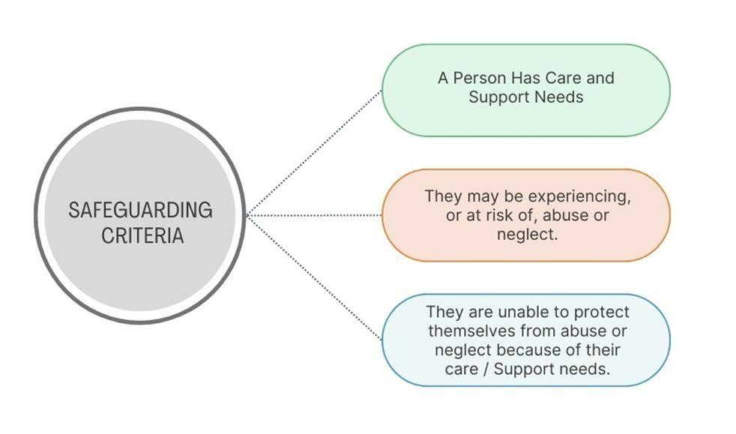
Where the answer is yes to all 3 of the above questions, then this constitutes a safeguarding concern, and the S42 statutory duty is engaged.
The local authority has a duty to make (or cause to be made) whatever enquiries it thinks necessary to enable it to decide whether any action should be taken and if so,

what should happen and by whom. This means that it may be more appropriate for the local authority to require others, such as health partners or care providers to make enquiries and report back to the local authority.
It is often necessary to gather information from other sources in relation to the people named in the concern. As such, the duty or allocated social worker/Adult MASH worker may share and receive information with/from other relevant partners to satisfy themselves that sufficient initial background checks have been established.
Initial contact should be made with the adult to ascertain their views about the situation, and to determine the outcomes they wish to see from the safeguarding process. The adult's needs in relation to communication, capacity and advocacy should also be considered. During the contact, immediate safety needs should be discussed, and support provided to ensure the safety of the person.
4.12 Decision Making
The Care Act (2014) states that skilful and knowledgeable supervision focused on outcomes for adults is critically important in safeguarding work. Managers have a central role in ensuring high standards of practice and that practitioners are properly equipped and supported. It is important to recognise that dealing with situations involving abuse and neglect can be stressful and distressing for staff and workplace support should be available (14.202). As such, regular and routine discussion should be completed and recorded within the decision-making process of the safeguarding.
Decision making should be defensible, and evidence based showing clear rationale for all decisions made.
A defensible decision is one where:
  - All reasonable steps have been taken to avoid harm
  - Reliable assessment methods have been used
  - Information has been collected and thoroughly evaluated
  - Decisions are recorded and subsequently carried out
  - Policies and procedures have been followed
  - Practitioners and their managers adopt an analytical approach and are proactive.
Decisions are defensible if they address the six points above, and:
  - Are recorded contemporaneously in a legible and approved system and format
  - Specify the rationale behind the decision in relation to the circumstances
  - Include references to relevant legislation and guidance
  - Are retained with other records about the individual (or organisation)
  - Are ‘signed’ and dated by the person making the record
4.13 In discussion with the team manager/senior social worker, the social worker/Adult MASH worker will need to decide the options available to proceed with the safeguarding.
No safeguarding response required: No safeguarding response required. This decision would result if further information gathered had indicated that the individual or the circumstances did not meet the criteria for a safeguarding concern. In this instance, the local authority must still offer information, advice and guidance. In accordance with Care Act responsibilities this includes financial advice, signposting to other agencies e.g. Police, NHS, CQC, Victim Support, Legal Advisors, Department for Work & Pensions (DWP) or the Office of the Public Guardian (OPG). The adult may benefit from a needs assessment and care management, in which case an appropriate referral must be made and recorded. If an informal or unpaid carer is involved, a Carers Assessment must be offered and recorded, if this is declined this should be recorded also. This decision must be communicated to the referrer so there is clarity regarding the decision and any related actions.
Safeguarding response: Where it is agreed that the concerns are not of a nature or degree that requires further progression under safeguarding arrangements, it does not suggest that the issues raised are not important or of significance, but rather that they should be managed in a different or more proportionate way. In such circumstances, the community/Adult MASH team may request someone else to advise of alternative sources of support or ways of managing the concern (for example, by signposting to a social worker for a reassessment of needs or to a specialist advisory service such as the Independent Domestic Violence Advisor (IDVA). This decision must be communicated to the referrer so there is clarity regarding the decision and any related actions.
Discretionary S42: Whilst statutory safeguarding duties relate to adults with needs of care and support, the Local Authority is also able to undertake discretionary enquiries, for example, where an adult may have support needs but not care needs. This situation might apply to a carer, a person believed to be self-neglecting or where, following interventions, significant risk remains to self or others. This decision must be communicated to the referrer so there is clarity regarding the decision and any related actions.
Statutory safeguarding enquiry in accordance with S42 of the Care Act: The S42 duty is engaged, and the local authority has a duty to make (or cause to be made) whatever enquiries it thinks necessary to enable it to decide whether any action should be taken and if so, what should happen and by whom. This means that it may be more appropriate for the local authority to require others, such as health partners or care providers to make enquiries and report back to the local authority. This then constitutes a formal Section 42 Enquiry. This decision must be communicated to the referrer so there is clarity regarding the decision and any related actions.
Where it appears that a crime has been committed, the Police will lead on the investigation and all necessary steps must be taken to preserve any evidence. Referral to the police should only happen if person at risk consents to Police action OR the adult lacks the capacity to make that decision OR the risk of harm or abuse affects others OR any refusal to agree to Police action appears to be based on coercion or threats. It is vital that a referral is made to the Police at the earliest possible opportunity. Police investigations should proceed as a part of a Section 42 enquiry and their early involvement may have benefits for the enquiry.
4.14 A formal Section 42 enquiry should be allocated to a qualified social worker within two working days of the decision being made. If it is not possible the reasons must be recorded.
The social worker must be suitably trained, experienced and considered competent to undertake the role of Enquiry Lead.
The adult or their family or advocate must be provided with the name and contact details of the person who will lead the enquiry, along with details of their manager and senior manager.
All actions, including referrals to other services, must be clearly recorded.
Team Managers/Senior Social Workers must oversee safeguarding enquiries and provide ongoing supervision and support to the Enquiry Lead.
Where there is a decision that a partner organisation or care provider will undertake an enquiry, the allocating Team Manager/Senior Social Worker must be satisfied that appropriate support and supervision is available.
4.15 Throughout this (and every) stage, it is important that the views and wishes of the person at risk are included within any decision-making. Such views may have been gathered at the point that concerns were raised, but there may be a need for further conversations to take place to decide how to respond to the concerns. People's views and outcomes will be subject to change and any changes must be acknowledged and documented within the safeguarding documentation.

These procedures are not process-driven – and exiting the enquiry is permissible when more proportionate alternatives are properly identified and put into place. Outcomes may be met through a variety of ways and risks can be addressed through alternative measures. These decsisions should be communicated to the referrer(s) and relevant parties to ensure clarity of information and decision making. Appropriate advice will be given to people about the options available to them. All decisions MUST be recorded and communicated
Each of the subsequent Stages of Safeguarding only relate to Section 42 Enquiries.

5 Stage 2: Section 42 Safeguarding Enquiry
5.1 A safeguarding enquiry can encompass a range of required activities (for example) from conversations with people, to changes in care and support, to changes in systems or processes, to repairing or maintaining key relationships, to the accessing of social justice & recovery etc.
A safeguarding enquiry can also encompass different types of investigations: for example: criminal, regulatory or personnel related. An assessment of risk will be necessary in all cases.
A safeguarding enquiry should not be undertaken prior to a planning discussion or meeting unless it is necessary for the immediate protection of the adult or others. The involvement of the adult at risk is particularly vital, so all consideration needs to be given to how to optimise inclusion and empowerment of the person most affected by the concern. This is consistent with the ethos of Making Safeguarding Personal.
The person has the right to refuse a safeguarding enquiry and consideration should be given to the person’s mental capacity to make the decision.

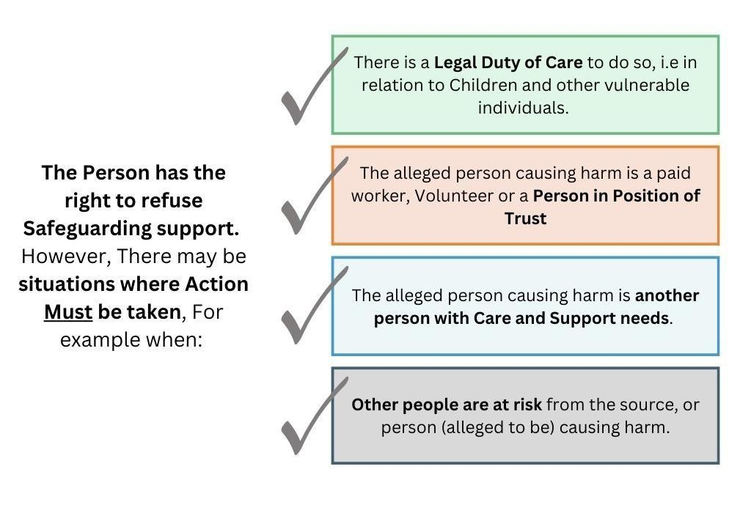

5.2 Capacity and Enquiries

Assessments of an adult's capacity are decision specific. If a capacity assessment is being undertaken, the following is considered:
  - Does the adult have the capacity to make decisions about aspects of the enquiry?
  - Does the adult have the capacity to make decisions about which concerns are raised in the referral / enquiry?
  - Does the adult have the capacity to consent to action being taken to address the concerns?
  - Is there any undue influence, coercion or duress? (This must be assessed).

5.3 Advocacy
Under the Care Act the local authority must arrange, where appropriate, for an independent advocate to represent and support an adult who is the subject of a safeguarding enquiry where the adult has 'substantial difficulty' in being involved in contributing to the process i.e. an adult who would otherwise have difficulty in understanding or communicating information and where there is no other suitable person, such as family or friend, to assist.
The advocate provides support to the adult to assist them in understanding the safeguarding process. The second role is representation, particularly in ensuring that the individual’s voice is heard, and the safeguarding process takes account of their views wherever appropriate.
The local authority must arrange, where appropriate, for an independent advocate to represent and support an adult who is the subject of a safeguarding enquiry where the adult has ‘substantial difficulty’ in being involved in contributing to the process and where there is no other appropriate adult to assist.
A person who is engaged professionally to provide care or treatment for the adult in question cannot be an advocate, nor can a family member or friend who is implicated within the safeguarding allegation.
In addition, if the person does not agree with the person who is proposed as advocate (and they have the capacity to make this decision) then they cannot be appointed, or if the friend or relative does not want to represent the person. It is not appropriate to ask a family member who would struggle practically to attend meetings, to understand the process themselves or who does not seek the adult’s opinion but only provides their own. The adult must also consent to being represented and supported by the advocate (or where the adult lacks capacity, the local authority must consider it in that adult’s best interests to be represented and supported by the advocate).
However, if an enquiry needs to start urgently, then it can begin before an advocate is appointed, but one must be appointed as soon as possible. In such cases, all agencies should set out how the services of advocates can be accessed, and the role they should take.
5.4 Risk assessment
A safeguarding risk assessment should be completed to assess and identify the level of risk to the person at risk and develop risk management plans. The risk assessment needs to identify and balance different perceptions of risk, including the adult, their carers and professionals; the adult’s right to make informed choices about taking risks should be safeguarded and encouraged. Decisions about risk, however, do need to balance any risk to the public and the needs and wishes of the adult.
The safeguarding risk assessment and management plans should be based on a detailed assessment of the risk to the individual and any other vulnerable persons from neglect, domestic abuse, mental ill-health, misuse of drugs and alcohol, poverty or homelessness.
This will determine if immediate action is necessary to protect the safety of the person or others who may be at risk.
Where ongoing risk is recognised, risk management plans should be agreed and implemented. These need to be regularly reviewed through the safeguarding enquiry to prevent further abuse, manage identified risk, ensure a proportionate response to risk management and appropriate referrals made, including referral to MARAC where high risk domestic abuse is identified.
https://www.manchesterappp.co.uk/strengths-based-tools/#53_Positive_Risk_Tool

5.5 Planning
When it is decided that a safeguarding enquiry should be undertaken, the ensuing process should be planned, and this is a dynamic process. All safeguarding enquiries require planning and co-ordination. No agency should begin enquiries before a planning meeting or discussion has taken place, unless it is essential to secure the safety of the adult or others, or a serious crime has been committed and the Police need to act to ensure the preservation of evidence.
The planning discussion will determine the scope of the safeguarding enquiry and any parallel type(s) of investigation that may be required, e.g. criminal investigations, disciplinary processes etc. It can take the form of a discussion or meeting to agree an action plan clarifying the focus of the safeguarding enquiry and who should take the lead role.
Planning can be undertaken as a series of telephone conversations, or meetings with relevant people and agencies. In some cases, the complexity or seriousness of the situation will indicate that more formalised planning is required. The urgency of a response should be proportionate to the seriousness of the concerns raised, and the assessed level of risk.
Where it is agreed that a safeguarding planning meeting is required, a minute taker should be requested by the Enquiry Lead, allowing 5 days notice and using the minute taker request form (which can be found in part 3 of safeguarding policy and procedures).

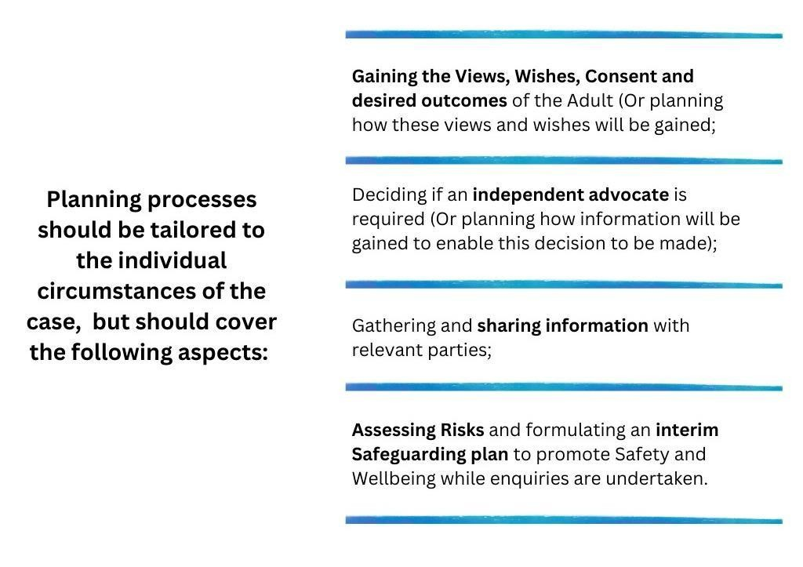

Proportionality is important – as holding meetings takes up time, office space, minute taking etc – and may not be the best use of limited resources. The involvement of the adult at risk is particularly vital, so all consideration needs to be given to how to optimise inclusion and empowerment of the person most affected by the concern.
Not all people at risk would like to attend a planning meeting or discuss personal aspects with (sometimes multiple) people who they have never met. Adult safeguarding procedures should allow for flexibility and creativity – and remove the restrictions of a linear process to be followed.
The Enquiry Lead and Team Manager/Senior Social Worker will decide on whether a meeting, discussion or range of discussions is the most appropriate and proportionate response.
Consideration of the risks to others needs to be factored into all decisions about adult safeguarding.

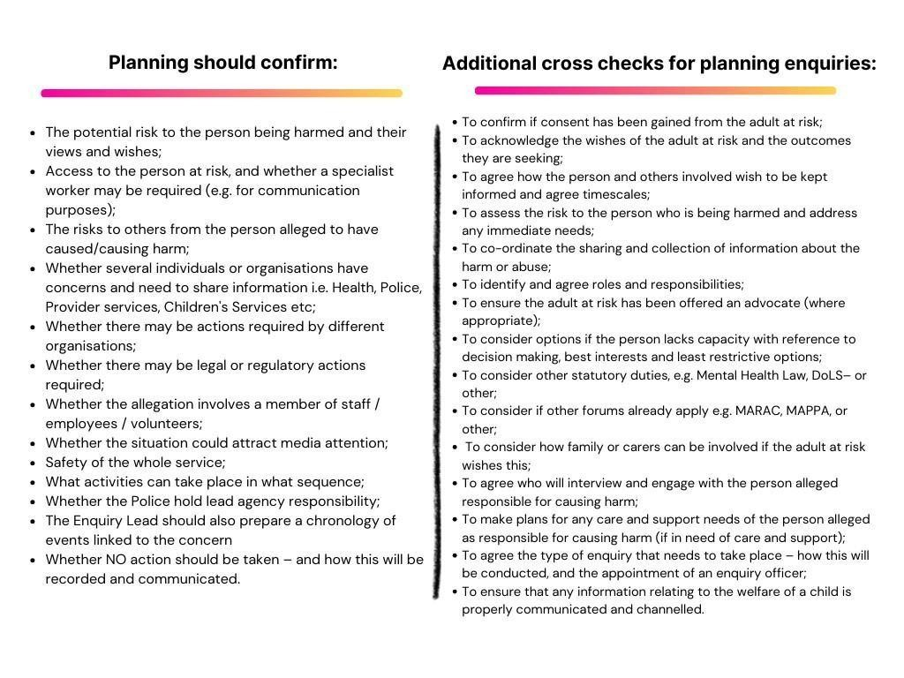

The Enquiry Lead is responsible for recording all actions taken within the planning process, using the appropriate Liquid Logic documentation and for wider sharing of agreed actions to all participants.

5.6 Enquiry
A safeguarding enquiry will reflect a wide range of activities and actions identified and agreed in the safeguarding plan to address the risks or harm identified. These may need to be undertaken by a variety of partners depending on the circumstances of the concern. Where this is the case, the process must be carried out in line with Making Safeguarding Personal ethos and practice.
The focus of a safeguarding enquiry should be on the impact and repercussions for the adult at risk. It should take account of the context of the situation so that decisions and plans for the adult's wellbeing and protection can be fully informed.
The specific objectives of an enquiry into abuse or neglect are also to, where necessary:
  - Establish facts;
  - Ascertain the adult's views, wishes and desired outcomes;
  - Protect the adult from abuse or neglect, in accordance with their wishes;
  - Assess the needs of the adult for protection, support and redress, and how these might be met;
  - Make decisions as to what action should be taken about the person or organisation thought to be the cause of risk;
  - Enable the adult to achieve resolution and recovery;
  - Add measures that protect others from abuse or neglect
There are no hard and fast rules and professional judgement need to be made about what type of enquiry and actions are right for each situation.
5.7 Who carries out an Enquiry
Although the local authority is the lead agency for making enquiries, it can require others to undertake these. The specific circumstances of the situation will often determine who is the right organisation or person to begin an enquiry.
All enquiries will require the input and supervision of the allocated social worker (Enquiry Lead), particularly with the more complex situations and to support the adult to realise the outcomes they want and to reach a resolution or recovery. However, in many cases a professional who already knows the adult will be the best person to support some of these discussions. They may be a social worker, a housing support worker, a GP or other health worker such as a community nurse or care provider.
The person carrying out the enquiry will need to be appropriately skilled and have sufficient resources to manage the required work objectively.
Those undertaking enquiries require appropriate sensitivity and skill to ensure minimal distress to the person. Personal and family relationships within community settings can prove both difficult to assess and complex regarding intervention. The dynamics of personal relationships can be challenging to judge and rebalance. For example, a person may make a choice to remain in a relationship that causes them emotional distress or financial harm, if they prefer to prioritise maintaining the relationship.
Professionals who might be asked to conduct a safeguarding enquiry:
- Social workers will be the most appropriate professionals to lead a safeguarding enquiry where abuse or neglect is suspected within a family or informal or formal care arrangement
- Police will be the appropriate agency to lead a safeguarding enquiry where a crime is suspected. Whilst the Police must lead the criminal investigation, local authority professionals may need to support this process for example, by providing information and assistance. The local authority has an on-going duty to promote the wellbeing of the adult in these circumstances
- Health professionals will be the most appropriate professionals to lead a safeguarding enquiry relating to health care and treatment plans for example, medicines management or pressure sores
- NHS and social care providers and employers will be the appropriate body to lead enquiries relating to internal care concerns, staff misconduct and poor practice issues in line with their HR and allegation management processes
- Contracts and quality monitoring staff based in Local Authorities and Clinical Commissioning Groups will be the appropriate professionals to lead safeguarding enquiries relating to concerns about quality of care or poor care, and to support service improvement processes
- Local authority and NHS commissioning teams are most appropriately placed to undertake enquiries relating to organisational abuse, repeating or escalating patterns of concerns, where the responsible individual for the service is implicated or where the provider is not considered to be competent to undertake the enquiry in an appropriate manner. In such circumstances, the commissioner will be undertaking an externally facilitated response
- Trading Standards will be the most appropriate organisation to lead a safeguarding enquiry regarding concerns relating to, for example: scams, rogue traders, doorstep crime
- Housing organisations and/or environmental health services will be the most appropriate organisations to undertake enquiries relating to anti-social behaviour
- Domestic violence and abuse services will be the most appropriate organisation to whom to make a referral when there are concerns about domestic abuse
- The Care Quality Commission will be the appropriate body to respond to regulatory breaches and non-compliance with mandatory standards of care.
  - A safeguarding visit is a critical element of risk assessment and opportunity to work with the adult at risk in an empowering way. The visit can take place either pre or as part of an enquiry. Ideally this would be within 48 hours of receiving the referral or more urgently if risks necessitate.
The Police must be consulted prior to making a visit where a crime may be indicated. Joint visits may be appropriate in certain circumstances. The visit is an opportunity to inform on aspects of safety as well as establish rapport with the person at risk, ensuring that their voice is heard and that their desired outcomes are explored.
During the visit the social worker leading the enquiry will ask the person for their own account of any situations highlighted in the safeguarding concern, (subject to consultation with the Police in cases of suspected crime) and to assess any risk of abuse they may be facing. This is the prime opportunity to explore the person's wishes and expectations of the outcome.
  - The Enquiry Lead may also:
- Assess the person's capacity to make informed choices about actions that could be taken to decrease any risk of abuse;
- Establish whether they give consent (if able to) for the procedures to be implemented and to information being shared with partner organisations;
- Establish their wishes for family members and/or informal carers to be informed or involved and whether they wish them to be included in any safeguarding meeting or next steps;
- Advise that consent can be overridden if (for example) a partner organisation needs to interview employees or other people as part of their duty to carry out an enquiry, or a criminal matter requires police attention;
- Inform the person (and their family/supporters) of their rights to make formal complaints and/or take other action;
- Offer advocacy services (where appropriate);
- Gain information about actions needed to address communication, assistance and physical access needs;
- Establish and clarify what the allegations of abuse are and obtain any necessary evidence;
- Assess the presenting risks and agree protection arrangements;
- Give information about the input that partner organisations could make to the risk assessment and to any safeguarding plan;
- Consider immediate needs for care and support or specialist input and advice

5.9 Enquiry within a regulated environment
If the allegation of neglect or abuse is about someone who is in a regulated service, such as a hospital, residential or nursing home or having a homecare service; the Care Act Statutory Guidance is clear that the provider should conduct an initial enquiry and report back to the Enquiry Lead and the planning meeting, unless there are good reasons why this is not appropriate, which should be recorded.
Before agreeing such an approach, the following considerations are required:
- There is no potential criminal investigation
- There is no clear conflict of interest (e.g. allegation of institutional abuse)
- There is no history of inadequate safeguarding enquiries
- There is just a single concern
The reasons for deciding the most appropriate organisation to conduct the enquiry must be recorded and confirmed during the planning meeting/on the action plan.
A copy of the Provider Led Enquiry template can be found in part 3 of adult safeguarding policy and procedures.

5.10 Parallel processes
Other processes, including criminal investigations, HR investigations and complaints investigations may need to run alongside the safeguarding enquiry but where possible, should not delay it.
For example, where there is a need for HR involvement, often the conclusion of the safeguarding enquiry will be required before the HR process can begin. Where there is a criminal investigation, the Enquiry Lead should be proactive in seeking information from the Police Investigating Officer.
Investigations can be complex and lengthy in duration. The safeguarding enquiry may be closed whilst a criminal investigation is ongoing, when the local authority is satisfied that it has discharged its Section 42 duty to undertake a Safeguarding Enquiry, and risks are managed, and a Safeguarding plan is in place. The Safeguarding enquiry closure forms must document the rationale for closure and ensure this is communicated to the Individual and all involved parties.

5.11 Disagreements
There will be instances where professionals may disagree on whether action is required or on the appropriate level of intervention. Respectful professional challenge and professional curiosity are encouraged in these procedures, providing that they are constructive and do not interfere with appropriate action being taken.
Disagreements will be noted in case notes and meeting minutes. It is essential that any disagreements are resolved professionally through constructive dialogue and a willingness to consider other points of view. No agency should unilaterally withdraw their involvement – where in doing so endangers adults at risk, or partner agencies, or others.
The Manchester Safeguarding Partnership Escalation and Resolution Protocol sets out standards and expectations regarding communication and a pathway to resolve or escalate concerns.
5.12 People who are believed to be a potential source of risk
It is important that the principles of natural justice are applied and that as far as is practically possible any person who is a potential source of risk is given details of the allegations against them and the opportunity to respond to allegations of abuse and/or neglect. Information sharing between partners and planning is imperative to avoid increasing the risks to a person or subjecting them to increased victimisation.
If the potential source of risk also has care and support needs, consideration should be given to their needs, and they should be offered any assessment or support that they may require. In the interests of independence and objectivity, separate workers should be allocated to support both individuals.
It is not appropriate to invite any person named or directly implicated as a source of risk to a safeguarding planning or outcomes meeting under these procedures.
5.13 Information sharing from a safeguarding enquiry
Anyone requested to undertake a safeguarding enquiry is under a duty to share the findings and outcomes of the enquiry together with any supporting documentation, with the Enquiry Lead and Team Manager/Senior Social Worker, so that a judgment can be made about the robustness of the response in resolving the situation and whether this has satisfactorily discharged the statutory safeguarding duty
A safeguarding enquiry report will be completed by the Enquiry Lead and will need to be sufficiently and proportionately detailed, including the following;
- A chronology of significant events
- An overview of the wishes and views of the adult and/or their representative
- An overview of how the adult and/or their representative have been involved in the enquiry
- A summary of the activity undertaken as part of the safeguarding enquiry
- A statement on the balance of probability, whether abuse or neglect has occurred • A summary of the actions taken to prevent repeat abuse or neglect • An overview of the outcomes achieved for the adult.
The person should receive or be offered a copy of their report – providing that copies of this do not raise risk factors to the person (e.g. domestic abuse, familial abuse in same household).

6 Stage 3: Safeguarding Plan and Review
6.1 The safeguarding plan formalises the actions required that safeguard the person against the identified abuse and neglect and offer resolution and recovery. In this regard, it should be proportionate and empowering of the person. Safeguarding plans can be put into place either during a safeguarding enquiry or at the end of the safeguarding enquiry stage.
The safeguarding plan should not be confused with a care and support plan; however, actions that may safeguard, protect or help monitor situations can form part of an ongoing care plan.
Whilst it is good practice to introduce a safeguarding plan, one may not be required in all cases. Where this is the case, a clear rationale should be recorded as to why a safeguarding plan was not made. This may be linked to support planning already in place or other unique strengths, networks and circumstances, or supports that is available to the person.
The safeguarding plan should be agreed and co-created with the involvement of the person at risk (or their representative). An easy read plan should be considered for clients who would benefit from pictorial information formats.

6.2 The Safeguarding Plan
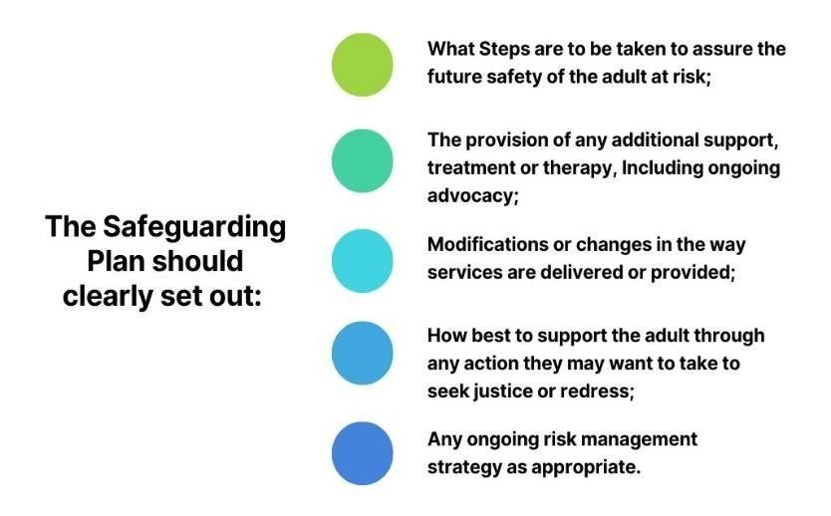
The safeguarding plan should outline the roles and responsibilities of all individuals and agencies involved and should identify the lead professional who will monitor and review the plan and include timescale for the review.

Adult safeguarding plans should be person-centred, and outcomes focused.
Safeguarding plans should be made with the full participation of the adult at risk. In some circumstances it may be appropriate for safeguarding plans to be monitored through ongoing care management responsibilities. In other situations, a specific safeguarding review may be required.
6.3 Reviewing the Safeguarding Plan
The Enquiry Lead in conjunction with the Team Manager/Senior Social Worker should monitor the plan within 28days.
In preparation of this review, it may be appropriate to seek the view of the Adult at Risk in relation to where or whether they would like meeting to be held (for example, they may want this meeting to be held in their home or a different location). They may wish to be accompanied by a trusted friend or family member.

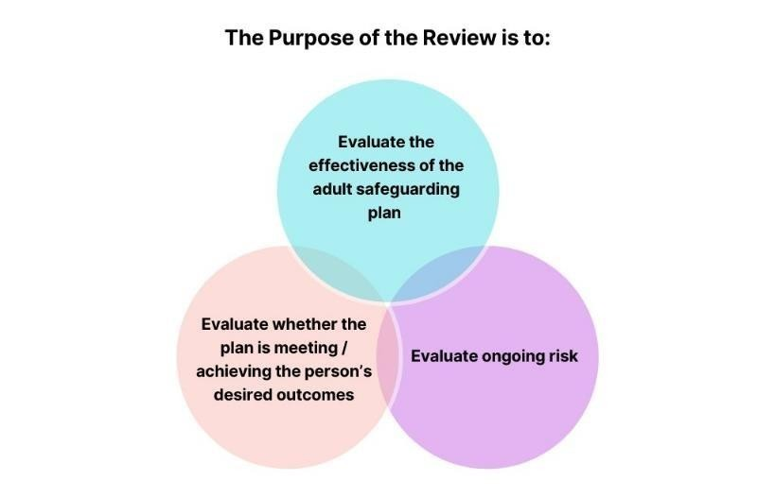

In some cases, a review meeting may be called, whereas in others a meeting will not be necessary. Following the review, it may be agreed that:
- The adult safeguarding plan is no longer required; or
- The adult safeguarding plan needs to continue.
Any changes or revisions to the plan should be made, new review timescales set (if required) and agreement reached regarding continued monitoring and review.
In consultation with the adult and/or their representative as well as the involved professionals, the Team Manager/Senior Social Worker will decide whether the outcome of the safeguarding enquiry requires a formal ‘Outcomes Meeting’ or whether this can be reasonably achieved through other forms of communication.
If it is agreed that no further action is required, the enquiry lead must inform the adult and/or their representatives, the referrer and all involved agencies of the outcome of the safeguarding enquiry as appropriate.
On rare occasions the review may indicate further or additional risks whereby a new adult safeguarding enquiry may need to be initiated. New safeguarding enquiries will only be triggered when necessary.
If the decision is that further safeguarding enquiries would be a disproportionate response to new or changed risks, then further review and monitoring may continue. A new safeguarding enquiry of this nature would prompt a planning meeting to be called.
6.4 Safeguarding outcomes meeting
A safeguarding outcomes meeting should be held upon completion of the enquiry. This is to enable a timely conclusion for the person. The safeguarding outcomes meeting provides an opportunity to feedback on the enquiry, exchange information, analyse risk, recommend responsibility for action and devise a plan for any further actions. This is also an opportunity to finalise the safeguarding support plan with the adult and key partners and consider the use of legal interventions.
The purpose of the safeguarding outcomes discussion or meeting is to:
- Review whether the adult's outcomes have been met FULLY, PARTIALLY or NOT MET
- Assess if the risks have been REMOVED, REDUCED, REMAIN, or INCREASED
- Discuss how any remaining risks might be addressed for the adult and/or other adults at risk
- Evaluate their satisfaction with the safeguarding intervention and the outcomes achieved
- Identify if any other actions are required to improve practice or to reinforce protection planning or ongoing monitoring arrangements
The level of recording of these discussions or meetings will vary from a short set of notes about whether the outcomes have been met or if not, any other action can be reasonably be taken to reduce any outstanding risks. Outcomes meetings must be accurately recorded by someone other than the Chair who is suitably experienced, using contemporaneous notes.
For cases of greater complexity, a minute taker should be requested by the Enquiry Lead, allowing 5 days notice and using the minute taker request form (which can be found in part 3 of safeguarding policy and procedures). A formal set of minutes should record decision making, outcomes and identification of any ongoing risks and protection planning that may be required.
These procedures allow for flexibility, proportionality and professional judgement.

7 Stage 4: Closing the Safeguarding Enquiry
7.1 Safeguarding processes can be ended at any stage.
7.2 Efforts should be made for all actions identified through the safeguarding enquiry to be carried out prior to the closure. However, it is recognised that there may be some actions that cannot be fully achieved prior to enquiry closure, this should not delay the closure. Where the Enquiry Lead is satisfied that risks have been removed or mitigated then the enquiry should be closed. The adult should be informed of the closure and asked if their desired outcomes have been addressed. Closures must be reviewed and signed off by Line Manager/Supervisor.
7.3 Safeguarding enquiry closure records should note the reason for this decision and the views of the person at risk to the proposed closure. The Enquiry Lead and Team Manager/Senior Social Worker should ensure that all agreed actions have been taken, building in any personalised actions such as:
- Agreement with the adult at risk to close safeguarding involvement;
- Making referrals for ongoing assessment and support;
- Providing advice and information;
- Updating/informing all organisations involved in the enquiry;
- Providing feedback to the referrer;
- Ensure that actions agreed concerning the person alleged to have caused harm, have been completed;
- Taking action to support other vulnerable adults;
- Making a referral to children's services (if necessary);
- Completing referrals to DBS or professional bodies;
- Noting outcomes which are evaluated by the adult at risk, and assessing whether these have been met;
- Identifying any lessons to be learned and shared.
As part of the safeguarding closure process, consideration should be given for a review of the care and supports needs of the person at risk.
Managers should ensure that all relevant documents have been uploaded to the council’s data recording system and these have been signed off.
  - Closing safeguarding enquiries down when other processes continue.
The adult safeguarding enquiry may be closed but other processes may continue, for example, a disciplinary or professional body investigation. These processes may take some time to complete and consideration may need to be given to the impact of these on the adult and how this will be monitored.
Where there are outstanding criminal investigations and pending court actions, the adult safeguarding procedures can also be closed providing that the adult is adequately safeguarded. Conversely, such cases can remain open to safeguarding providing there is an appropriate safeguarding plan in place and there is a clear rationale as to why the case should not be closed.
Agreements for the enquiry to remain open or be closed should be reached during the outcomes meeting with relevant partners and the person at risk.
  - Evaluation of outcomes by the adult at risk.
If the adult at risk disagrees with the decision to close safeguarding down, their reasons should be fully explored to ensure risk is managed. In some cases, it will be necessary and good practice to carry out an additional review of the safeguarding plan within 28days.
This will be to establish that the adult at risk is still 'safeguarded' and if any additional resources should be directed for ongoing safety. This review should be scheduled and communicated to relevant partners.
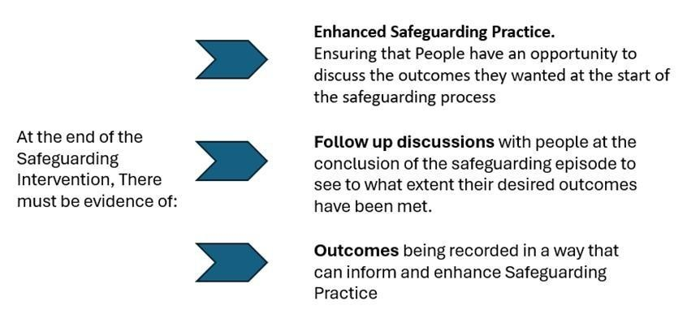

8 Timescales
8.1 The adult safeguarding procedures do not set definitive timescales; however, target timescales are indicated in the table below. Agreed timescales should be case specific and reflect the ethos of Making Safeguarding Personal.
It is important that timely action is taken whilst respecting the principle that the views of the adult at risk are paramount. It is the responsibility of all agencies to proactively monitor concerns to ensure that drift does not prevent timely action and place people at further risk.
8.2 Table of indicative timescales

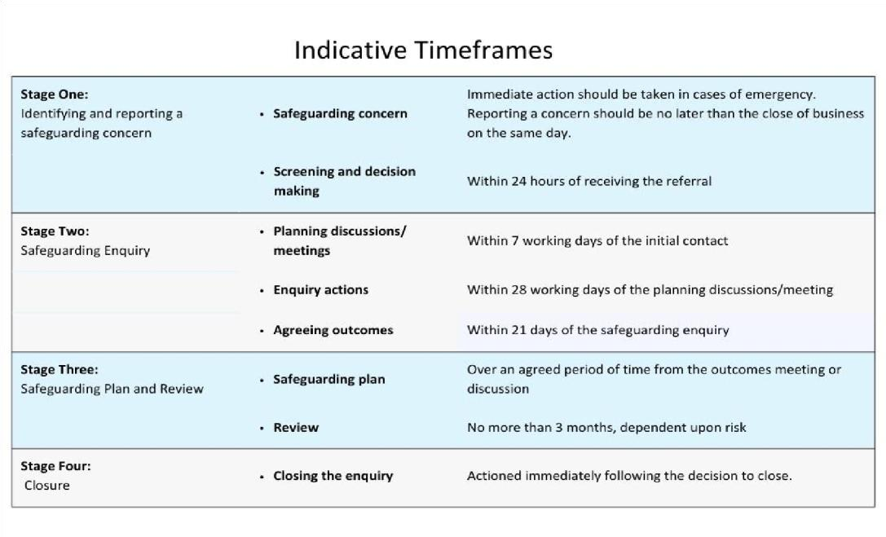

8.3 Variation of any agreed timescales may be justified where:
- Adherence to the agreed timescales would jeopardise achieving the outcome that the adult at risk wants;
- It would not be in the best interests of the adult at risk;
- Significant changes in risk are identified that need to be addressed;
- Supported decision making may require an appropriate resource not immediately available;
- The person's physical, mental and/or emotional wellbeing may be temporarily compromised.

9. Organisational Abuse
9.1 A complex/large scale enquiry would take place when organisational abuse is indicated.
The definition of organisational abuse is:
Organisational abuse includes neglect and poor care practice within an institution or specific care setting such as a hospital or care home, for example, or in relation to care provided in one’s own home. This may range from one off incidents to on-going illtreatment. It can be through neglect or poor professional practice as a result of the structure, policies, processes and practices within an organisation. (care and support statutory guidance 14.17)
9.2 A complex/large scale enquiry is required in the event of an allegation of organisational abuse, but it may also include some of the following additional factors:
- Potential for media interest
- High volume and severity of risk
- Culture of dangerous practices
- The need for high level coordinated response
- Single or several people/organisations with significant power and authority to cause considerable harm
9.3 The purpose of a complex/large scale enquiry is to:
- Ensure the safety and well-being for all adults involved, both individually and collectively.
- Arrange and coordinate a multi-agency enquiry to reduce risk of harm and protect adults.
- To focus on the enquiry of the alleged abuse or neglect. Other aspects of unsafe practice will be addressed by other processes e.g. contract/quality monitoring.
  - Decision making, coordination and management of complex/large scale enquiries will be determined by Service Managers or Head of Service from Adult Social Care in consultation with senior managers from other relevant agencies.
  - To determine if a complex/large scale enquiry is required the following is to be considered:
- Does it meet the organisational abuse definition?
- Do the concerns raised need to be investigated by an overarching complex/large scale enquiry; due to risks that cannot be effectively managed through individual safeguarding procedures?
- Is more complex coordination and planning required?
9.6 Complex/large scale enquiries may involve a wide range of organisations and several individual Safeguarding Adults processes and enquiries. They can often cross local authority boundaries and may involve services that are not commissioned by health or social care. It is therefore crucial such processes are tightly coordinated and managed.
The different roles and responsibilities of some key organisations are detailed below:
- The Host Authority - will have overall responsibility for coordinating the safeguarding enquiry and for ensuring clear communication with all placing authorities, especially with regards to the scheduling of meetings.
- The Placing Authority - will have a continuing duty of care to the adult they have placed. They will contribute to the enquiry as required and retain overall responsibility for the individual they have placed.
- Adults, family and friends and their advocates - the adults and their families are central to any safeguarding enquiry and the Safeguarding Adults Procedures stress the importance of their involvement at all stages. This is no less important in complex and large-scale enquiries, although practically, it may be necessary to arrange separate meetings because of numbers. There is an added dimension in that if the enquiry relates to a provider providing services to a group of people some of those individuals may not be subject to abuse, however, they may need to be informed of the wider issues so they can make informed judgments about their own service.
- Commissioners (Health, or Local Authority) - all Commissioners must ensure through contracts and service specifications, or service level agreements, that the provider has arrangements in place for protecting adults at risk and for managing concerns. These must be compliant with Manchester’s multi-agency safeguarding adults policy and procedures. Placing commissioners should ensure that arrangements are in place for ongoing contract monitoring and review.
9.7 Pre-planning - before the planning meeting the following will apply.
- Consultation with the Police about possible criminal implications.
- Any urgent actions to safeguard adults currently at risk must take place immediately and not wait for the planning meeting.
- The need for a communications strategy including who will be the single point of contact.
- What information will be immediately shared with providers to enable them to:
      - protect adults at risk in their care.
      - take appropriate employer’s action if required.
      - have the opportunity to respond to any allegations.
- Should the use of the services be temporarily suspended for new users whilst further information is gathered through the enquiry process?
- Individual enquiries should not be delayed whilst waiting to convene a planning meeting.
- Where there are safeguarding concerns about specific individuals a safeguarding adults concern should be recorded for each individual.
- Are there additional processes which need immediately engaging e.g. contract monitoring visits, care management reviews?
9.8 Planning - preparing a complex/large scale enquiry:
- Organise a planning meeting within a maximum of 5 working days from the date that the need is identified. The timescale will be determined by the perceived level of risk. It can be extended if there are valid reasons for the delay which are evidenced within case recording.
- Identify who needs to be involved, which agencies and placing authorities and in what capacity e.g. attendance at meeting, submission of report or for information only.
- Consider who would not be involved following consultation with appropriate professionals such as legal services and police (e.g. person alleged to have caused harm if involving them would contaminate a police enquiry)
- Identify who will be responsible for chairing meetings (Service manager or Head of Service) and taking the minutes.
- Consider other policies and procedures to be taken into consideration. For example: Person in Position of Trust policy (PIPOT) or serious incident review (SIR).
- Work to an agreed agenda
- Consider the best way to involve the provider in the enquiry process:
o Who is the most appropriate person or people to represent the provider depending on the allegation?
        - the manager of the service provider
        - the senior/regional manager
        - the owner o How the service provider will be involved in the planning meeting
        - invitation to the full planning meeting
        - invitation to part of the planning meeting
        - a separate meeting with the provider to discuss allegations
Please note: in rare circumstances it may not be appropriate to invite the provider. In such case advice should be sought to ensure the rights of providers are upheld.
If the meeting is undertaken in two parts then minutes must reflect the different discussions and attendees should only receive minutes for the part which they attended.

9.9 The Complex/Large Scale Planning Meeting
The meeting will begin with attendees signing a confidentiality agreement and signing in. The planning meeting will:
- Share the concerns and allegations
- Share general knowledge concerning the provider/person/s causing harm
- Share information from the provider if appropriate
- Consider what information will be shared with the person/persons alleged to have caused harm
- Clarify adults affected
- Assess the immediate risk of harm to current users of the service and determine if any immediate actions are required which will include:
  - Individual protection plan actions
  - Actions for provider
- Agree terms of reference for the enquiry so it is manageable and achievable.
- Receive a report from the lead commissioner/ quality monitoring officer if applicable to assist in making a decision about a recommendation of a temporary stop on using the service whilst the enquiry takes place
- Consider other policies and procedures to be taken into consideration.
- Identify roles and responsibilities and resources required for undertaking the enquiry i.e. the coordinating enquiry lead from the host authority and identified point of contact from partners and any other staffing or resources required
- Ensure there is a clear communications strategy which will include communication with:
  - All adults, families, carers and advocacy services (including Independent Mental Capacity Advocate (IMCA) services where appropriate).
  - Service Provider
  - Person/persons of concern
  - Identify designated person within the key organisations who will be the single point of contact for their organisation
  - Agree how other placing authorities, (i.e. of individuals not identified as alleged victims) will be informed of the concerns raised and who will do this.
  - Agree how commissioners of the service – including specialist commissioners will be informed of the concerns and who will do this.
  - Consideration needs to be given about media interest and briefing
Communications Team, relevant senior managers and legal representatives - Consideration needs to be given to informing risk and insurance if appropriate - This communication strategy must be reviewed regularly.
- Minutes of the planning meeting will be taken and shared with participants and those who were invited and unable to attend. If the meeting is undertaken in two parts then minutes must reflect the different discussions and attendees should only receive minutes for the part which they attended.
- Consider if major incident procedures are invoked including what contingency plans are required.
- Consider contingency plans should the risks escalate.

9.10 The Complex/Large Scale Enquiry
It is important that the Host Authority monitors the process and timescales of the enquiry. It should not go more than 20 working days from the initial planning meeting without liaison with the key people identified at that meeting to ensure enquiries are progressing appropriately.
Complex/large scale enquiries usually require a number of organisations and people to carry out enquiries and enquiries appropriate to their role. This will require robust management and coordination by the Chair.
Such enquiry/enquiries could include the following:
- Individual service user enquiries.
- Police enquiry into possible criminal offences
- CQC inspections
- Care contract monitoring
- Enquiry into financial viability and sustainability of a provider
- Health care assessment e.g. pharmacy, Continuing Health Care, tissue viability involvement.
- Meetings individually or collectively with users, and or relatives or advocates
- Assessment/reviews of users by placing authorities Social Care or Health)
- Service Provider enquiries or response to allegations
Due to the wide ranging nature of complex/large scale enquiries it is likely these enquiries will take some time. To ensure enquiries are progressing in line with the terms of reference, additional meetings, and or agreed feedback mechanisms/communication strategies may be required.

9.11 Outcomes of the Complex/Large Scale Enquiry
When the enquiry is completed a multi-agency outcomes meeting will be held; no later than 10 working days from the completion of the enquiry. If there are justified reasons for delaying the meeting, these should be recorded and an appropriate date set.
If the enquiry has identified risks which require management immediately this will be communicated to the most appropriate person/agency to ensure that protective arrangements are made. Each individual safeguarding enquiry will need to be concluded for the findings to be fed into the complex/large scale enquiry outcomes meeting.
All outcomes meetings will be arranged, organised and chaired by the Host Authority. It is the responsibility of the Host Authority to make the enquiry report(s) available to all relevant agencies and people prior to this meeting.
The purpose of the complex/large scale enquiry outcomes meeting is:
- To share the outcome of the individual safeguarding enquiries relating to the safeguarding concern
- To share final reports from all key agencies
- To identify any differing views and the potential implications of these
- To agree the process of communicating the outcome of the enquiry outcomes meeting with any adults, their families, carers or advocates who are not present at the meeting
- Agree who else (individuals or agencies) needs feedback about the outcomes and how this will be achieved
- Agree what feedback is given to the person/persons causing harm
- Determine what follow up actions are required and who is tasked with doing these.
- Determine if the complex/large scale enquiry can be closed
- Determine if monitoring or actions are required through a different process
- Determine if a review is required in relation to the complex/large scale enquiry or if individual reviews are needed.
- Consider if a safeguarding adults review (SAR) is required. If so, it should be referred to the Manchester Safeguarding Partnership for consideration.

All enquiries will conclude with outcomes. That is:
- whether the adults at risk of harm are now safe,
- the action required by various agencies,
- any actions against individuals or organisations. This may require individual judgements where there are a number of separate allegations.

There may be protection plan/s for individuals affected AND there may also be other actions required such as:
- Multi-agency actions:
  - changes in policies, procedures or practices.
- Contract and commissioning actions:
  - suspension of placements, application of contracting sanctions, implementation of a service improvement action plan
- Consideration of whether a Safeguarding Adults Review is needed.
- Ongoing police enquiries
- Ongoing CQC action
- Actions in relation to person/persons who has/have caused harm
Minutes of the Outcomes Meeting will be taken and shared with attendees and those who were invited and unable to attend. See local templates.
A Complex/Large scale enquiry will only be closed following an Outcomes Meeting where there is multiagency agreement that there is evidence the risk of harm has been reduced and the service is operating safely.
If a review is required this should be undertaken within a maximum of 60 working days. The timescale should be determined at the Outcomes Meeting.

9.12 Considerations in Transitional Situations
Safeguarding Children’s procedures cover children and young adults up to the age of 18 years. Safeguarding Adults procedures cover all adults from the age of 18 years.
When an alleged victim is over the age of 18 years by the time the safeguarding incident is reported, but the alleged incident occurred prior to the individual reaching 18 years, any enquiry into the concern will be led by Children and Young People’s services.
When an alleged adult at risk is over 18 and the alleged incident occurred after they were 18, any enquiry into the concern will be led by Adults Services.
If concerns are raised about a provider that provides services for individuals both under and over the age of 18, such as specialist colleges, the host authority will be responsible for clarifying whether their children or adults safeguarding services will act as Chair/Managing Officer, and coordinate any enquiry necessary.
Generally adult safeguarding procedures must be implemented for anyone over 18 years and in these situations Children’s Services must be equal partners throughout the process so any issues that impact on Children’s Services can be identified, addressed and monitored. These situations may be complicated by the different procedures timescales and processes for each. The shortest timescales should be met. In these situations the following issues will need to be considered:
- The Chair should be the Adult lead. There should also be appropriate representation from Children’s Services
- Information sharing
- The law and regulations which govern both the adult at risk and children
- Enquiries should be undertaken jointly between adults and children’s services so both aspects are considered.
The protection arrangements, will be the responsibility of either Children or Adults services, as follows:
- Where a young person over the age of 18 is supported by Children’s Services under “leaving care” arrangements, the Care Act 2014 states that safeguarding concerns should be dealt with through Adult safeguarding arrangements (Statutory Guidance Ch.14.5)
- If the responsibility for care management of a young person in transition but aged under 18 lies with Children’s Services when the safeguarding concern is raised, responsibility will remain with this service throughout the enquiry.
- In all other cases, the protection arrangements would be the responsibility of adult services.

10. Version control, communication and cascading
10.1 It is important that version control is managed and maintained by those writing or reviewing policy documents to ensure that adult social care staff are consistently using the most up to date version of policy.
10.2 Any amendment to the original policy should be recorded in the version control table on the front page. It should state the version of the document being amended, provide a description of the change, by who and on what date, with the revised version being made explicit on the original front-page table.
10.3 Once a new policy has been completed and signed off by DMT or a review of policy has been finalized, this should be communicated effectively to all adult social care staff.
10.4 The Policy Assurance Group will forward a copy to the Business Improvement Team who will ensure it is included in the prospective adult social care broadcast. Business Improvement Team - cfmessage@manchester.gov.uk

11. Storage and access to policy
11.1 The Adult Safeguarding Policy and Procedures will be stored on the Adult Policy Procedure and Practice Portal (APPP) which can be accessed here https://www.manchesterappp.co.uk/
11.2 APPP will maintain a spreadsheet on behalf of MCC (Manchester City Council) adult social care that will list local active policies and the dates in which they are due for review.
11.3 The Policy Assurance Group (PAG) will be notified by our partners at APPP when a particular policy is due for review, who will contact the owner of the policy to prompt review.

